**Tableau Projects**

Welcome to my Tableau Projects repository! Here, you'll find a collection of five different Tableau dashboards that I've created, each focusing on a unique aspect of data visualization and analysis. These projects were developed using real-time data extracted from various datasets on Kaggle.

**AirBnB Final Project**

For the AirBnB Final Project, I utilized a comprehensive dataset to showcase a detailed analysis and visualization, which includes a wide range of data from AirBnB listings, reviews, and calendar information. This project represents the culmination of my Tableau skills, bringing together various techniques and insights. Below, you'll find the dataset used and a sample screenshot of the dashboard.

**Dataset Name:** AirBnB Dataset

**Dashboard:**

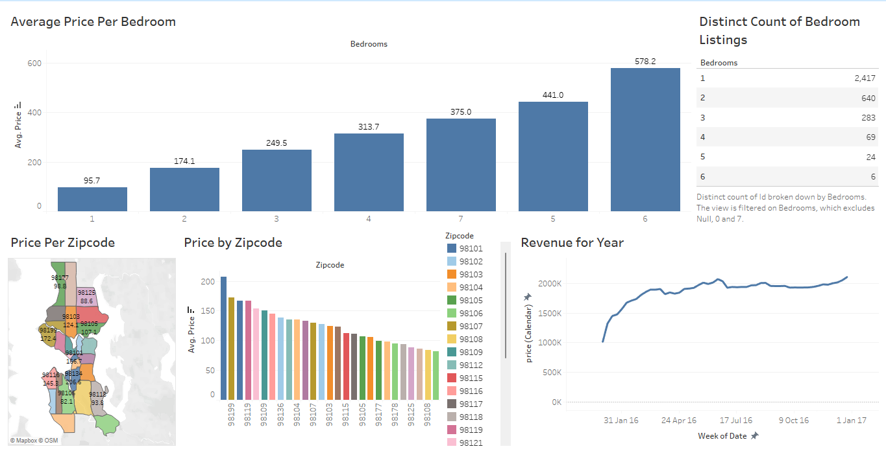

**Sample Picture of AirBnB Final Project Dataset:**

**Listings Sheet Dataset:**



**Reviews Sheet Dataset:**



**Calendar Sheet Dataset:**

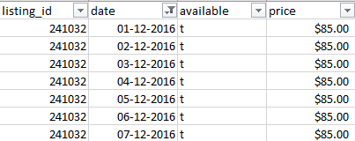

**Other Projects**

The following projects were created using the 'vgsales', 'directory', and 'joins' datasets, which include a wide range of data from video game sales, store directories, and employee records. These datasets capture various details such as game names, platforms, sales data, store locations, and more.

1. **Introduction to Tableau:**

**Dataset Name:** vgsales

**Dashboard:**

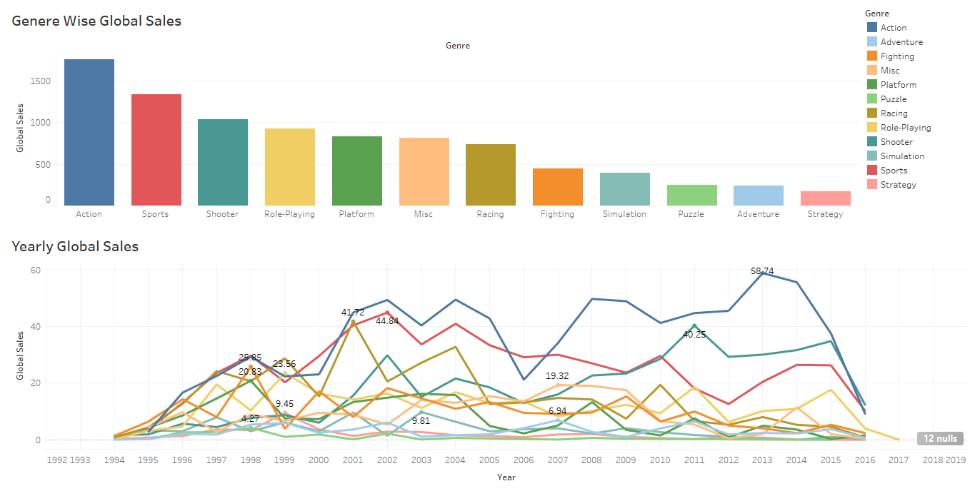

1. **Calculated Fields and Bins:**

**Dataset Name:** vgsales

**Dashboard:**

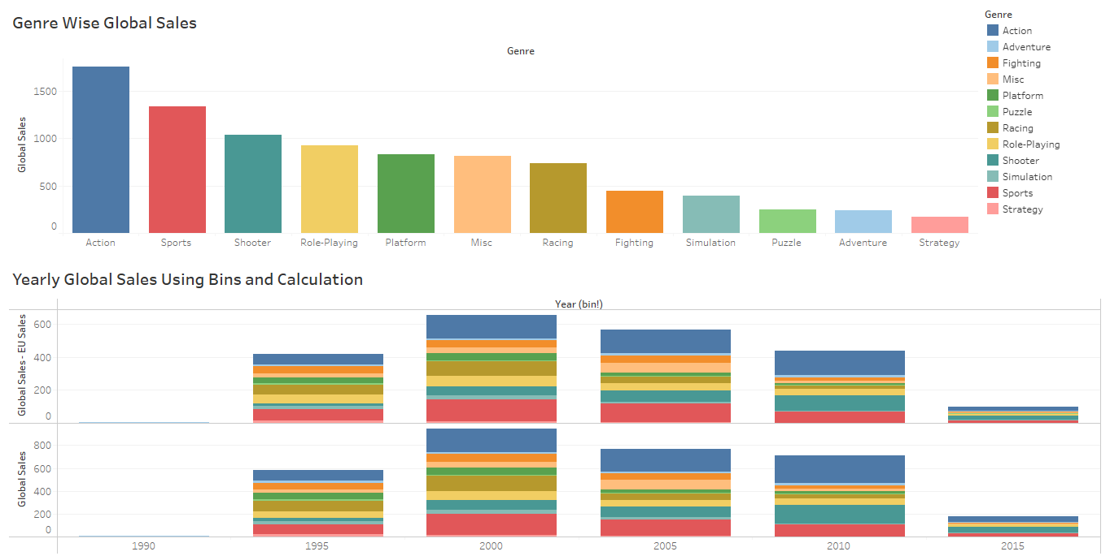

1. **Visualizations:**

**Dataset Name:** vgsales and directory

**Dashboard:**

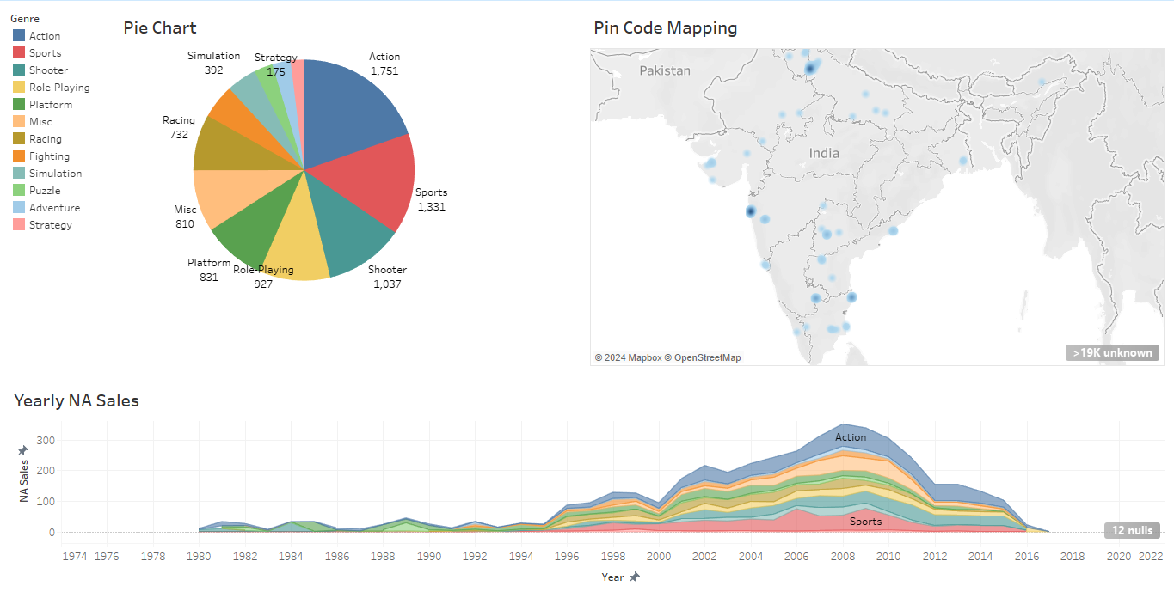

1. **Joins:**

**Dataset Name:** Joins dataset (Excel file containing Demographics, JobTitle, and sheets)

**Dashboard:**

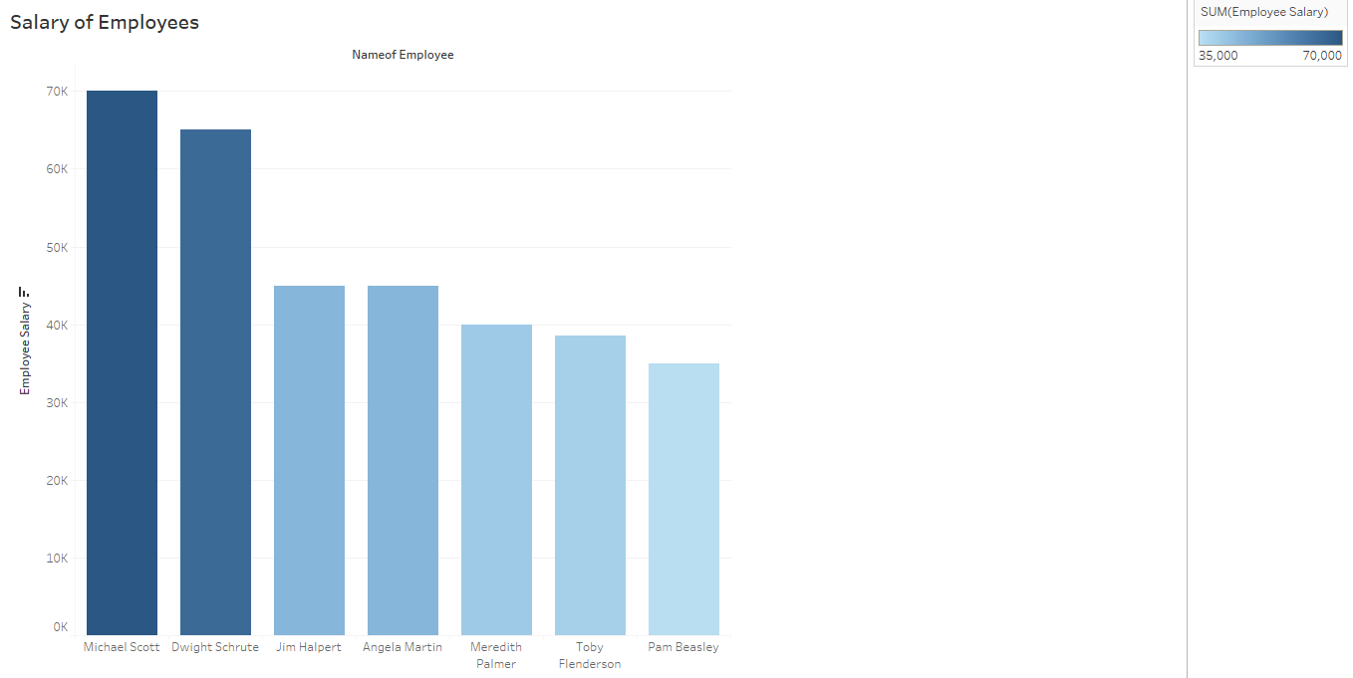

**Sample Photos of vgsales, Joins, and Directory Datasets:**

**Vgsales:**

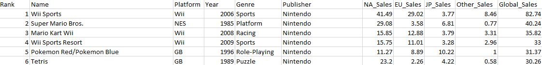

**Joins:**

**Demographics:**

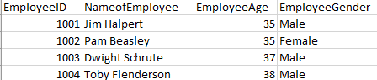

**JobTitle:**

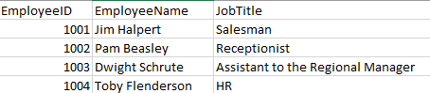

**Salary:**

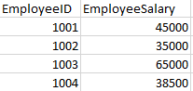

**Directory:**



**About the Datasets**

**AirBnB Dataset:** The 'AirBnB' dataset is a rich source of information gathered from AirBnB listings, reviews, and calendar data. It includes the following data points:

**Listings:**

* id, listing_url, scrape_id, last_scraped, name, summary, space, description, experiences_offered, neighborhood_overview, notes, transit, thumbnail_url, medium_url, picture_url, xl_picture_url, host_id, host_url, host_name, host_since, host_location, host_about, host_response_time, host_response_rate, host_acceptance_rate, host_is_superhost, host_thumbnail_url, host_picture_url, host_neighbourhood, host_listings_count, host_total_listings_count, host_verifications, host_has_profile_pic, host_identity_verified, street, neighbourhood, neighbourhood_cleansed, neighbourhood_group_cleansed, city, state, zipcode, market, smart_location, country_code, country, latitude, longitude, is_location_exact, property_type, room_type, accommodates, bathrooms, bedrooms, beds, bed_type, amenities, square_feet, price, weekly_price, monthly_price, security_deposit, cleaning_fee, guests_included, extra_people, minimum_nights, maximum_nights, calendar_updated, has_availability, availability_30, availability_60, availability_90, availability_365, calendar_last_scraped, number_of_reviews, first_review, last_review, review_scores_rating, review_scores_accuracy, review_scores_cleanliness, review_scores_checkin, review_scores_communication, review_scores_location, review_scores_value, requires_license, license, jurisdiction_names, instant_bookable, cancellation_policy, require_guest_profile_picture, require_guest_phone_verification, calculated_host_listings_count, reviews_per_month.

**Reviews:**

* listing_id, id, date, reviewer_id, reviewer_name, comments.

**Calendar:**

* listing_id, date, available, price.

**vgsales Dataset:** The 'vgsales' dataset is a comprehensive collection of video game sales data. It includes the following data points:

* Rank, Name, Platform, Year, Genre, Publisher, NA_Sales, EU_Sales, JP_Sales, Other_Sales, Global_Sales.

**Directory Dataset:** The 'Directory' dataset captures various details about stores and their locations. It includes the following data points:

* Brand, Store Number, Store Name, Ownership Type, Street Address, City, State/Province, Country, Postcode, Phone Number, Timezone, Longitude, Latitude.

**Joins Dataset** The 'Joins' dataset is an Excel file that contains three sheets with the following data points:

**Demographics:**

* EmployeeID, NameofEmployee, EmployeeAge, EmployeeGender.

**JobTitle:**

* EmployeeID, EmployeeName, JobTitle.

**Salary:**

* EmployeeID, EmployeeSalary.

Feel free to explore each Tableau file and dataset to see how I've utilized this data to create insightful and visually appealing dashboards.